Day 13 - 28th June 2025
TASK 1:
POINTERS
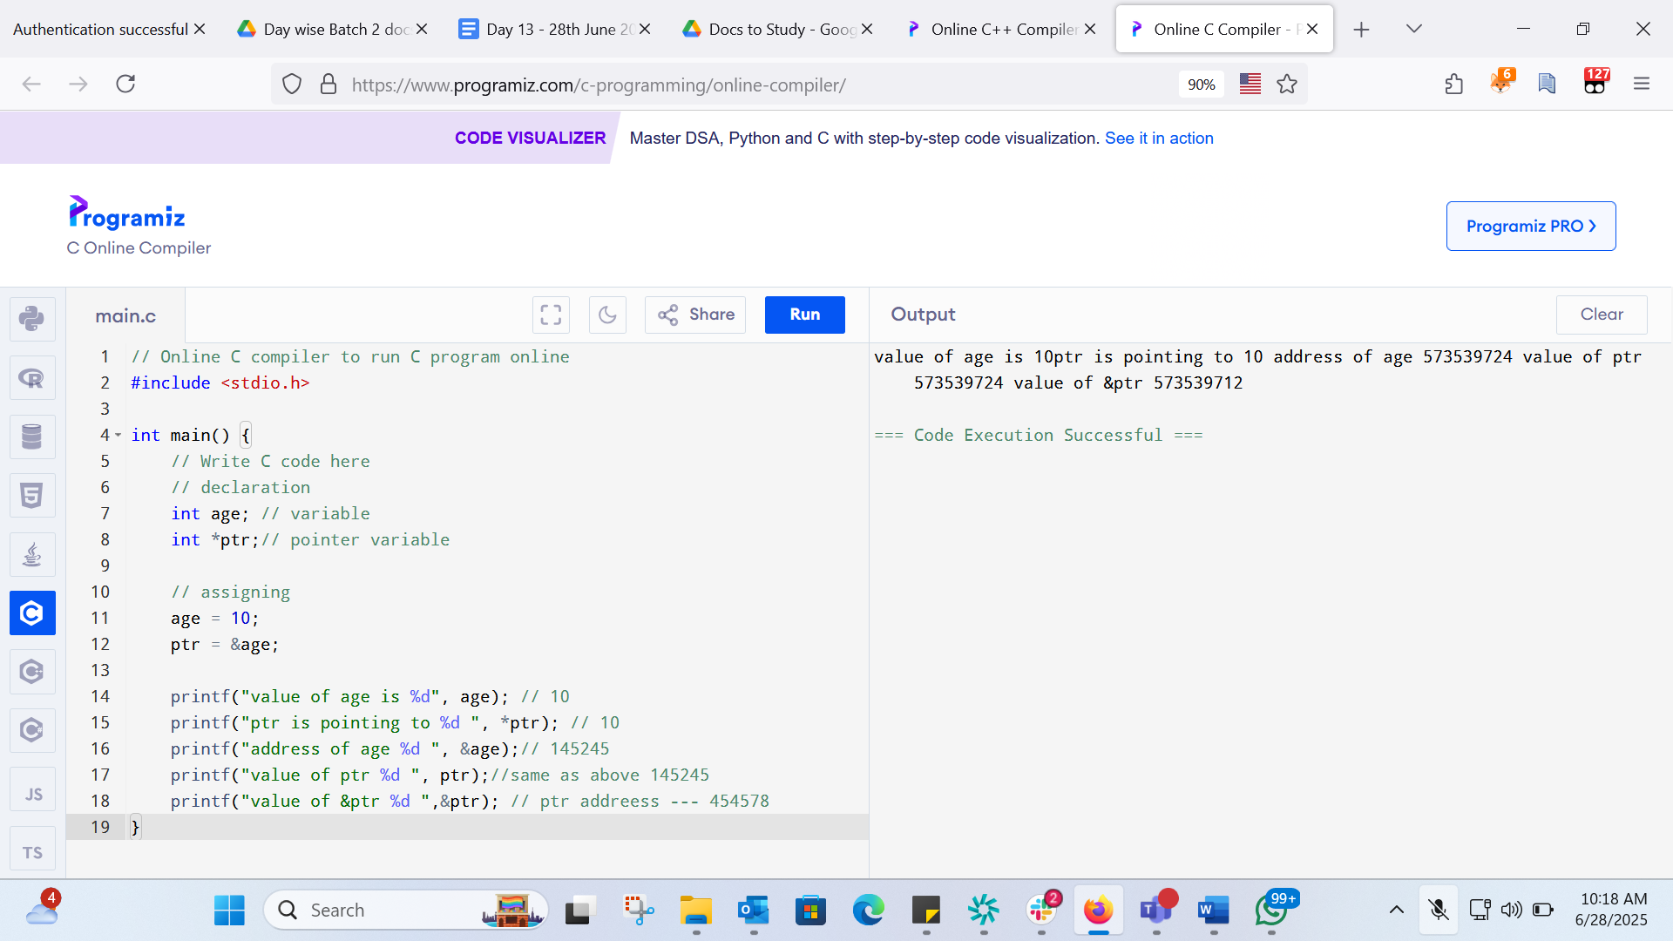
// Online C compiler to run C program online
#include <stdio.h>

int main() {
// Write C code here
// declaration
int age; // variable
int *ptr;// pointer variable

// assigning
age = 10;
ptr = &age;

printf("value of age is %d\n", age); // 10
printf("ptr is pointing to %d \n", *ptr); // 10
printf("address of age %d \n", &age);// 145245
printf("value of ptr %d \n", ptr);//same as above 145245
printf("value of &ptr %d \n",&ptr); // ptr addreess --- 454578
}
C++
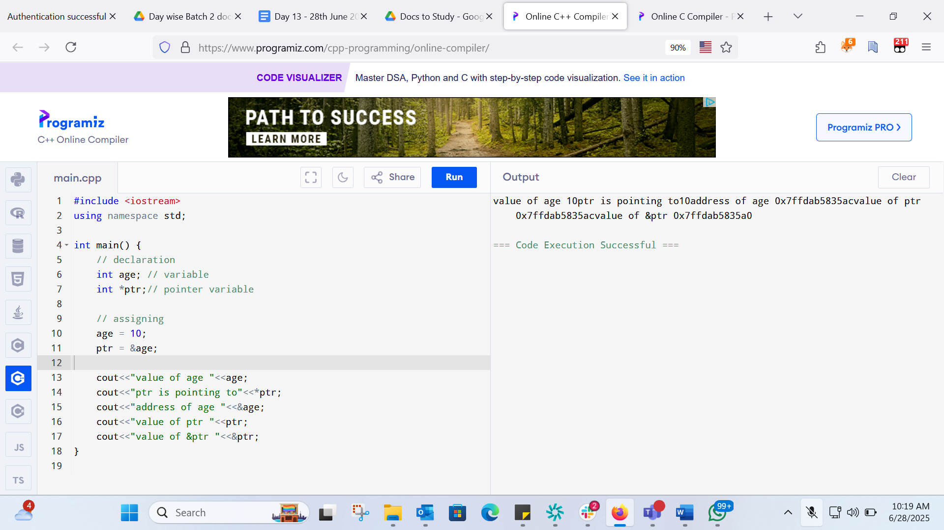#include <iostream>
using namespace std;

int main() {
// declaration
int age; // variable
int *ptr;// pointer variable

// assigning
age = 10;
ptr = &age;

cout<<"value of age "<<age<<"\n";
cout<<"ptr is pointing to "<<*ptr<<"\n";
cout<<"address of age "<<&age<<"\n";
cout<<"value of ptr "<<ptr<<"\n";
cout<<"value of &ptr "<<&ptr<<"\n";
}
TASK 2:
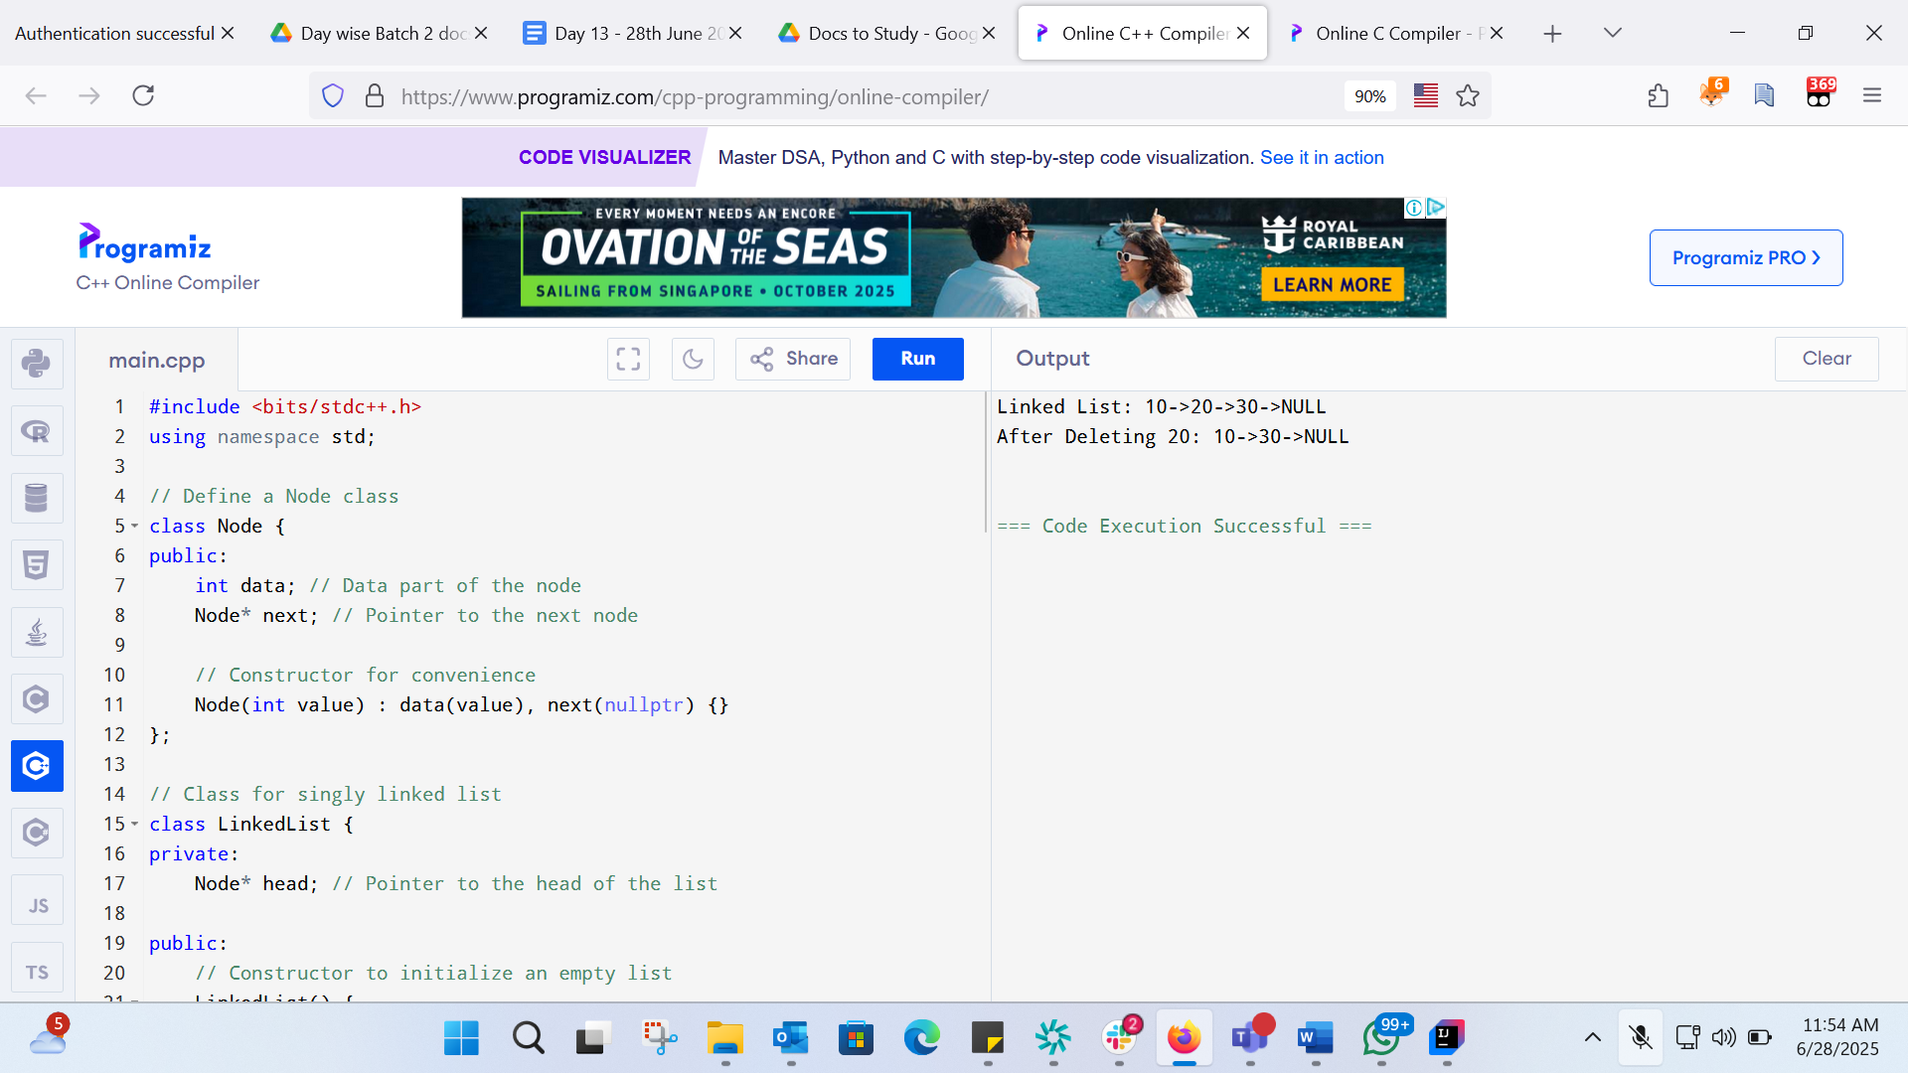
#include <bits/stdc++.h>
using namespace std;

// Define a Node class
class Node {
public:
int data; // Data part of the node
Node* next; // Pointer to the next node

// Constructor for convenience
Node(int value) : data(value), next(nullptr) {}
};

// Class for singly linked list
class LinkedList {
private:
Node* head; // Pointer to the head of the list

public:
// Constructor to initialize an empty list
LinkedList() {
head = nullptr;
}

// Function to insert a node at the end
void insertAtEnd(int value) {
Node* newNode = new Node(value);
if (head == nullptr) {
head = newNode; // If list is empty, make newNode the head
} else {
Node* temp = head;
while (temp->next != nullptr) {
temp = temp->next; // Traverse to the last node
}
temp->next = newNode; // Link the last node to newNode
}
}

// Function to delete a Node by Value
void deleteByValue(int value) {
if (head == nullptr) {
return;
}
if (head->data == value) {
Node* temp = head;
head = head->next; // Move head to the next node
delete temp; // Free memory of the deleted node
return;
}
Node* temp = head;
while (temp->next && temp->next->data != value) {
temp = temp->next; // Traverse to find the node to delete
}
if (temp->next) {
Node* nodeToDelete = temp->next;
temp->next = temp->next->next; // Unlink the node
delete nodeToDelete; // Free Memory
}
}

// Function to display the list
void display() {
Node* temp = head;
while (temp != nullptr) {
cout << temp->data << "->";
temp = temp->next;
}
cout << "NULL" << endl;
}

// Destructor to free all allocated memory
~LinkedList() {
Node* temp;
while (head) {
temp = head;
head = head->next;
delete temp;
}
}
};

int main() {
LinkedList list;
list.insertAtEnd(10);
list.insertAtEnd(20);
list.insertAtEnd(30);
cout << "Linked List: ";
list.display();
list.deleteByValue(20);
cout << "After Deleting 20: ";
list.display();
return 0;
}
TASK 3:
TASK 4 :Try to create a node and add a value to it.. Which can take any kind of data in the Node..
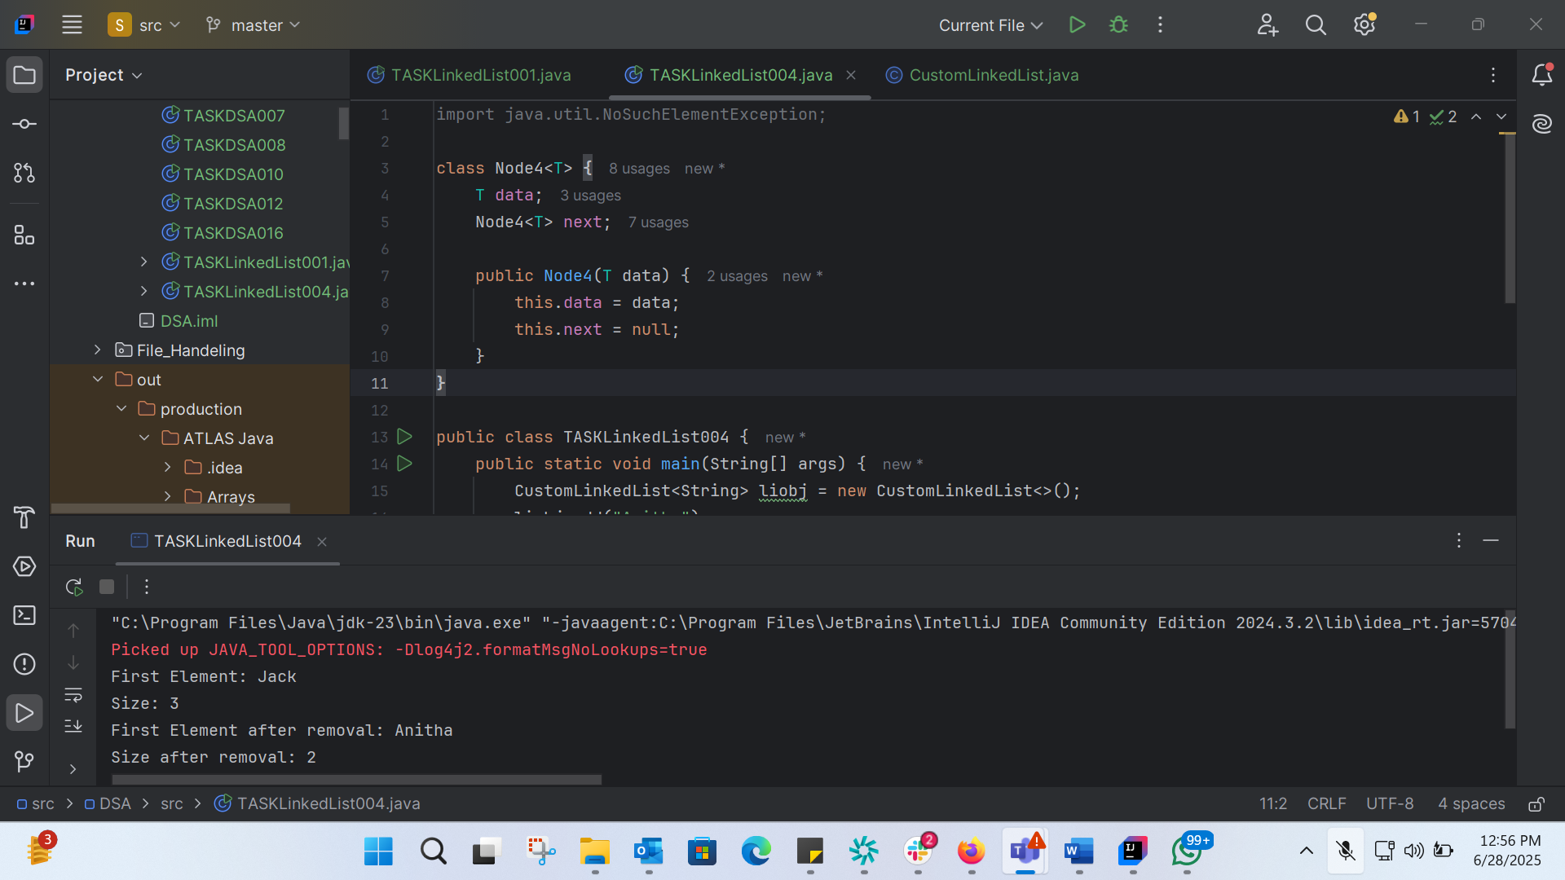
import java.util.NoSuchElementException;
class Node4<T> {
T data;
Node4<T> next;
public Node4(T data) {
this.data = data;
this.next = null;
}
}
public class TASKLinkedList004 {
public static void main(String[] args) {
CustomLinkedList<String> liobj = new CustomLinkedList<>();
liobj.add("Anitha");
liobj.add("Verma");
liobj.addFirst("Jack");
System.out.println("First Element: " + liobj.get(0));
System.out.println("Size: " + liobj.size());
liobj .removeFirst();
System.out.println("First Element after removal: " + liobj.get(0));
System.out.println("Size after removal: " + liobj.size());
}
}

TASK 5: List down all the methods of Linked list
Basic Methods
1. add(T data): Adds an element to the end of the list.
2. addFirst(T data): Adds an element to the beginning of the list.
3. addLast(T data): Adds an element to the end of the list (similar to add(T data)).
4. removeFirst(): Removes the first element from the list.
5. removeLast(): Removes the last element from the list.
6. get(int index): Retrieves an element at a specific index.
7. size(): Returns the number of elements in the list.
Element Retrieval Methods
1. getFirst(): Retrieves the first element from the list.
2. getLast(): Retrieves the last element from the list.
3. indexOf(T data): Finds the index of a specific element in the list.
4. contains(T data): Checks if the list contains a specific element.
Element Removal Methods
1. remove(T data): Removes the first occurrence of a specific element from the list.
2. remove(int index): Removes an element at a specific index from the list.
List Modification Methods
1. clear(): Removes all elements from the list.
2. set(int index, T data): Replaces an element at a specific index with a new value.
List Inspection Methods
1. isEmpty(): Checks if the list is empty.
2. toArray(): Converts the list to an array

TASK 06:
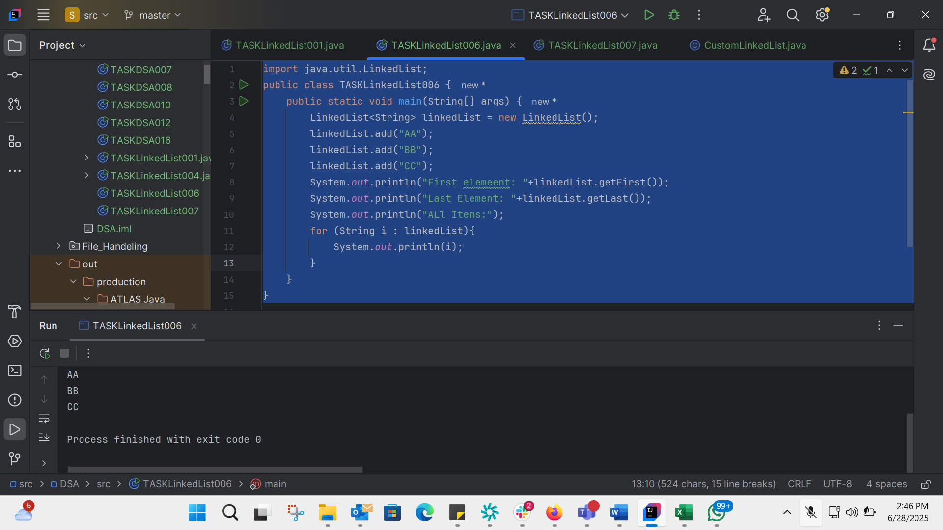
import java.util.LinkedList;
public class TASKLinkedList006 {
public static void main(String[] args) {
LinkedList<String> linkedList = new LinkedList();
linkedList.add("AA");
linkedList.add("BB");
linkedList.add("CC");
System.out.println("First elemeent: "+linkedList.getFirst());
System.out.println("Last Element: "+linkedList.getLast());
System.out.println("ALl Items:");
for (String i : linkedList){
System.out.println(i);
}
}
}

TASK 07:
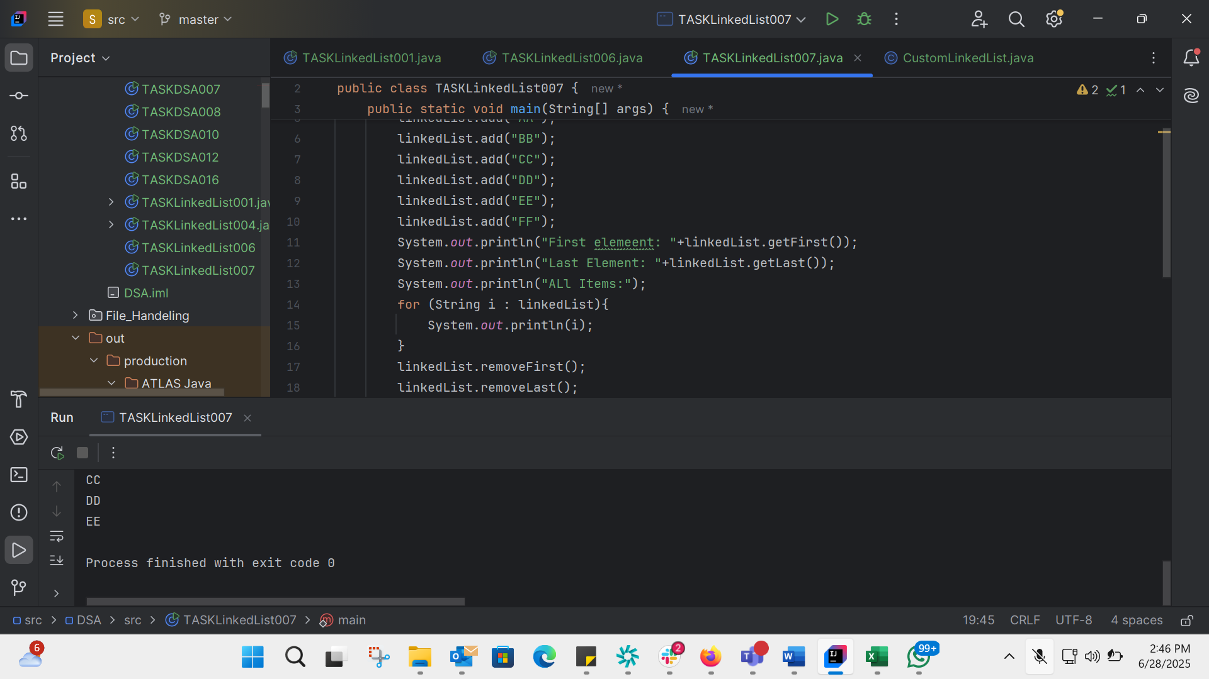
import java.util.LinkedList;
public class TASKLinkedList007 {
public static void main(String[] args) {
LinkedList<String> linkedList = new LinkedList();
linkedList.add("AA");
linkedList.add("BB");
linkedList.add("CC");
linkedList.add("DD");
linkedList.add("EE");
linkedList.add("FF");
System.out.println("First elemeent: "+linkedList.getFirst());
System.out.println("Last Element: "+linkedList.getLast());
System.out.println("ALl Items:");
for (String i : linkedList){
System.out.println(i);
}
linkedList.removeFirst();
linkedList.removeLast();
System.out.println("After Deleting: ");
for (String i : linkedList){
System.out.println(i);
}
}
}
TASK8:
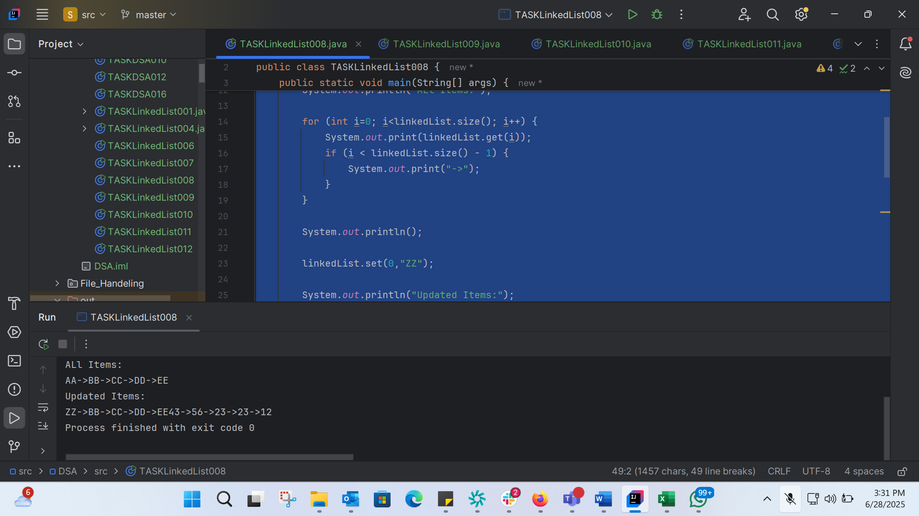
import java.util.LinkedList;
public class TASKLinkedList008 {
public static void main(String[] args) {
LinkedList<String> linkedList = new LinkedList();
linkedList.add("AA");
linkedList.add("BB");
linkedList.add("CC");
linkedList.add("DD");
linkedList.add("EE");
System.out.println("First elemeent: "+linkedList.getFirst());
System.out.println("Last Element: "+linkedList.getLast());
System.out.println("ALl Items:");
for (int i=0; i<linkedList.size(); i++) {
System.out.print(linkedList.get(i));
if (i < linkedList.size() - 1) {
System.out.print("->");
}
}
System.out.println();
linkedList.set(0,"ZZ");
System.out.println("Updated Items:");
for (int i=0; i<linkedList.size(); i++){
System.out.print(linkedList.get(i));
if (i<linkedList.size()-1){
System.out.print("->");
}
}
LinkedList<Integer> linkedListint = new LinkedList();
linkedListint.add(43);
linkedListint.add(56);
linkedListint.add(23);
linkedListint.add(23);
linkedListint.add(12);
for (int i =0; i<linkedListint.size(); i++){
System.out.print(linkedListint.get(i));
if (i<linkedListint.size()-1){
System.out.print("->");
}
}
}
}

TASK 9:
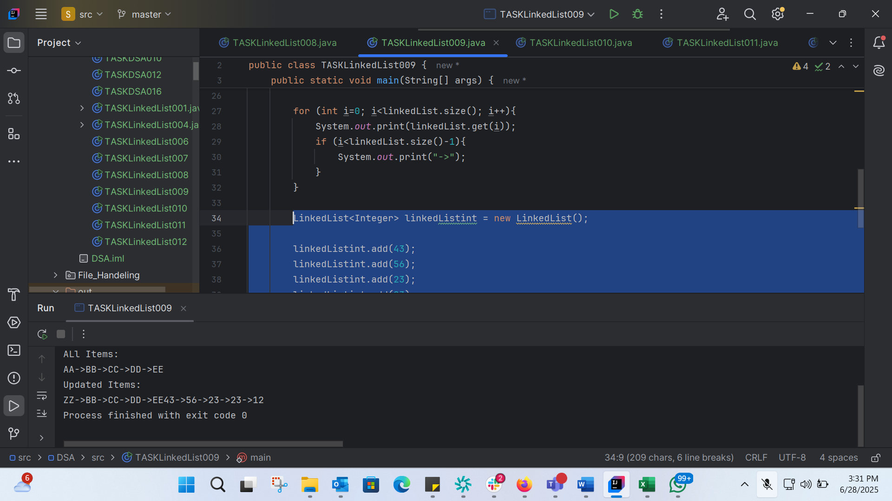
import java.util.LinkedList;
public class TASKLinkedList009 {
public static void main(String[] args) {
LinkedList<String> linkedList = new LinkedList();
linkedList.add("AA");
linkedList.add("BB");
linkedList.add("CC");
linkedList.add("DD");
linkedList.add("EE");
System.out.println("First elemeent: "+linkedList.getFirst());
System.out.println("Last Element: "+linkedList.getLast());
System.out.println("ALl Items:");
for (int i=0; i<linkedList.size(); i++) {
System.out.print(linkedList.get(i));
if (i < linkedList.size() - 1) {
System.out.print("->");
}
}
System.out.println();
linkedList.set(0,"ZZ");
System.out.println("Updated Items:");
for (int i=0; i<linkedList.size(); i++){
System.out.print(linkedList.get(i));
if (i<linkedList.size()-1){
System.out.print("->");
}
}
LinkedList<Integer> linkedListint = new LinkedList();
linkedListint.add(43);
linkedListint.add(56);
linkedListint.add(23);
linkedListint.add(23);
linkedListint.add(12);
for (int i =0; i<linkedListint.size(); i++){
System.out.print(linkedListint.get(i));
if (i<linkedListint.size()-1){
System.out.print("->");
}
}
}
}

TASK 10:
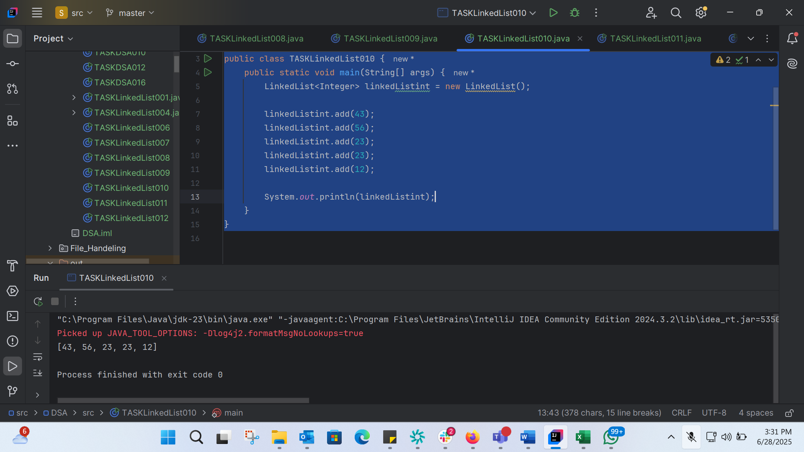
import java.util.LinkedList;
public class TASKLinkedList010 {
public static void main(String[] args) {
LinkedList<Integer> linkedListint = new LinkedList();
linkedListint.add(43);
linkedListint.add(56);
linkedListint.add(23);
linkedListint.add(23);
linkedListint.add(12);
System.out.println(linkedListint);
}
}
TASK11: 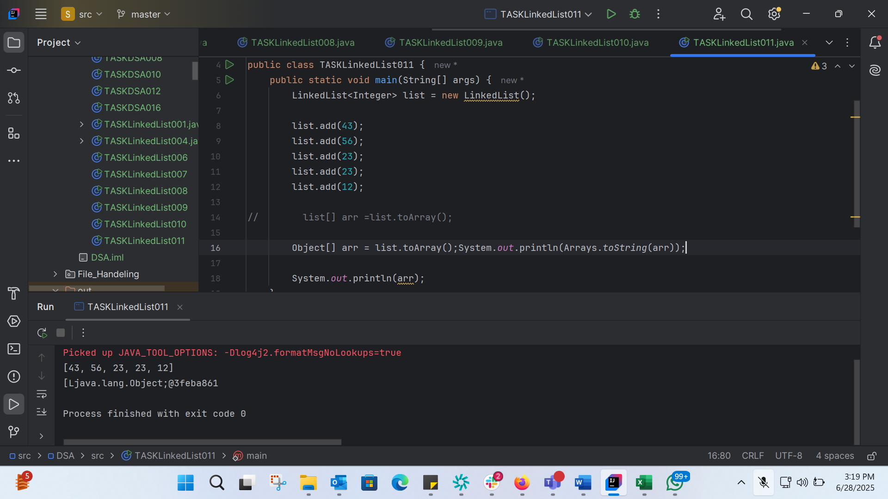
import java.util.Arrays;
import java.util.LinkedList;
public class TASKLinkedList011 {
public static void main(String[] args) {
LinkedList<Integer> list = new LinkedList();
list.add(43);
list.add(56);
list.add(23);
list.add(23);
list.add(12);
// list[] arr =list.toArray();
Object[] arr = list.toArray();System.out.println(Arrays.toString(arr));
System.out.println(arr);
}
}
TASK 12: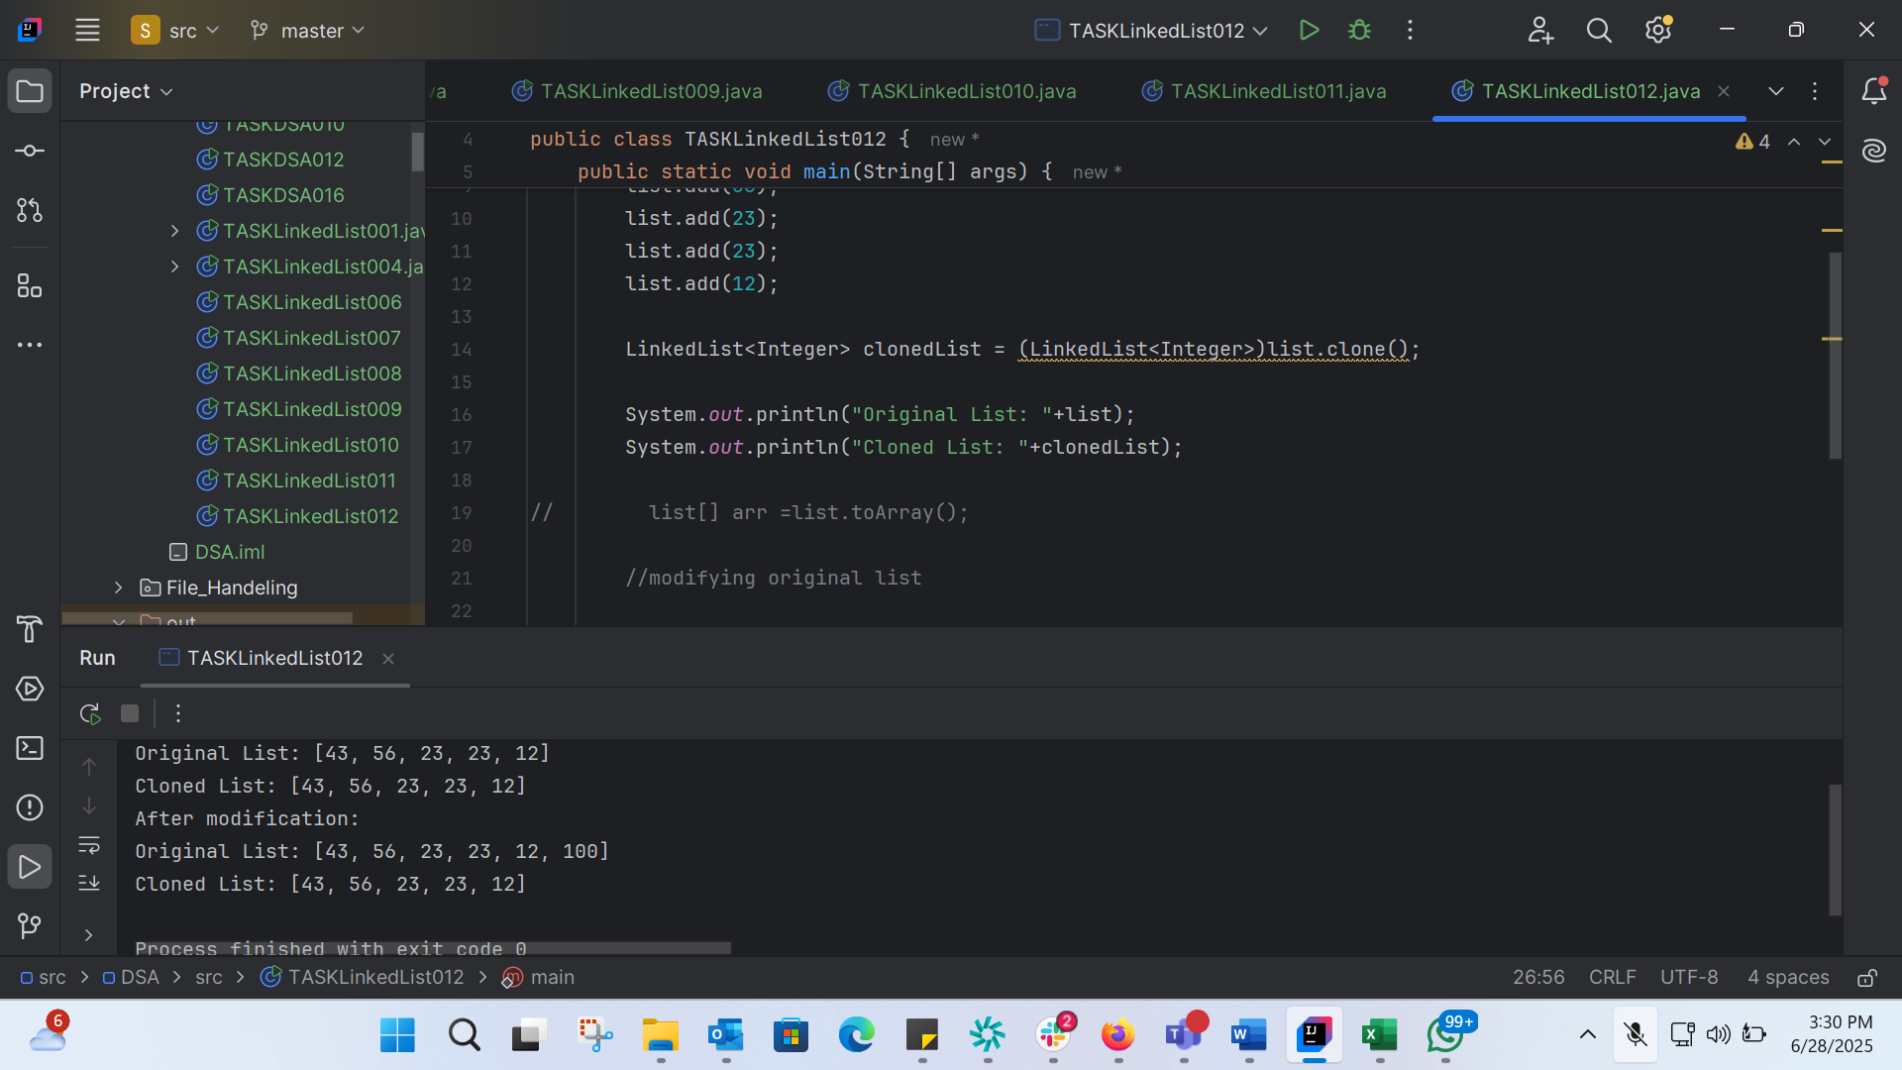
import java.util.Arrays;
import java.util.LinkedList;
public class TASKLinkedList012 {
public static void main(String[] args) {
LinkedList<Integer> list = new LinkedList();
list.add(43);
list.add(56);
list.add(23);
list.add(23);
list.add(12);
LinkedList<Integer> clonedList = (LinkedList<Integer>)list.clone();
System.out.println("Original List: "+list);
System.out.println("Cloned List: "+clonedList);
// list[] arr =list.toArray();
//modifying original list
list.add(100);
System.out.println("After modification: ");
System.out.println("Original List: "+list);
System.out.println("Cloned List: "+clonedList);
}
}

TASK 13: 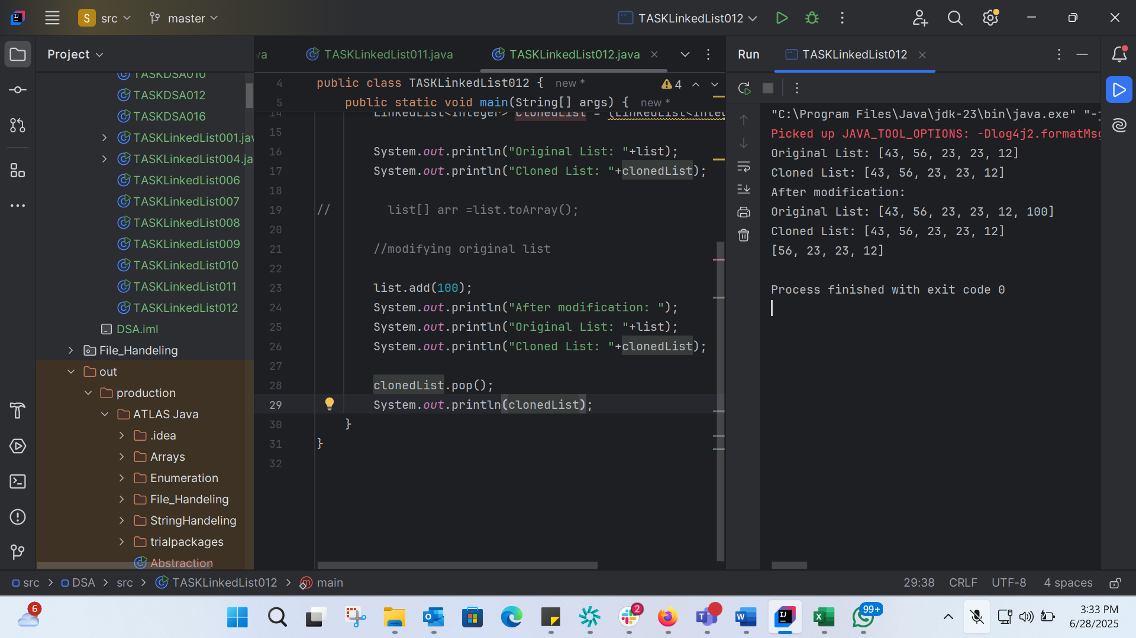
import java.util.Arrays;
import java.util.LinkedList;
public class TASKLinkedList012 {
public static void main(String[] args) {
LinkedList<Integer> list = new LinkedList();
list.add(43);
list.add(56);
list.add(23);
list.add(23);
list.add(12);
LinkedList<Integer> clonedList = (LinkedList<Integer>)list.clone();
System.out.println("Original List: "+list);
System.out.println("Cloned List: "+clonedList);
// list[] arr =list.toArray();
//modifying original list
list.add(100);
System.out.println("After modification: ");
System.out.println("Original List: "+list);
System.out.println("Cloned List: "+clonedList);
clonedList.pop();
System.out.println(clonedList);
}
}
TASK 14:
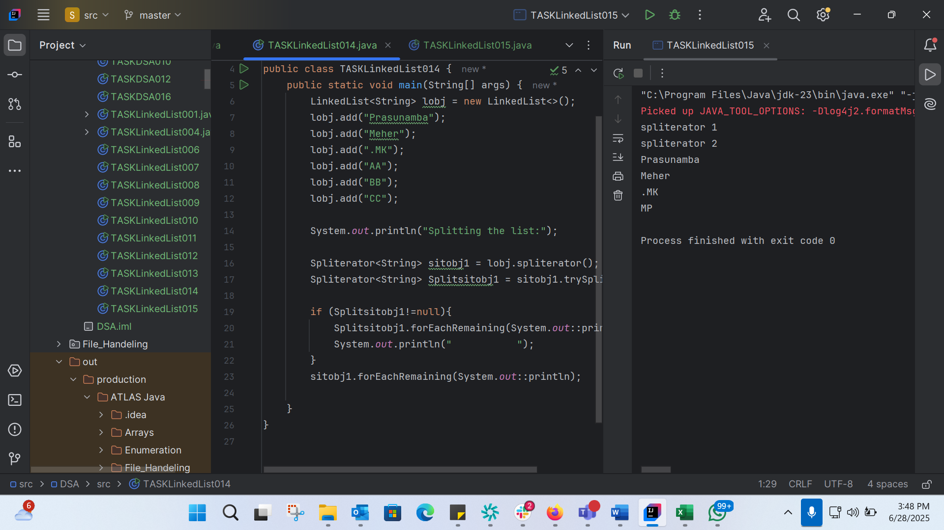
TASK 15:
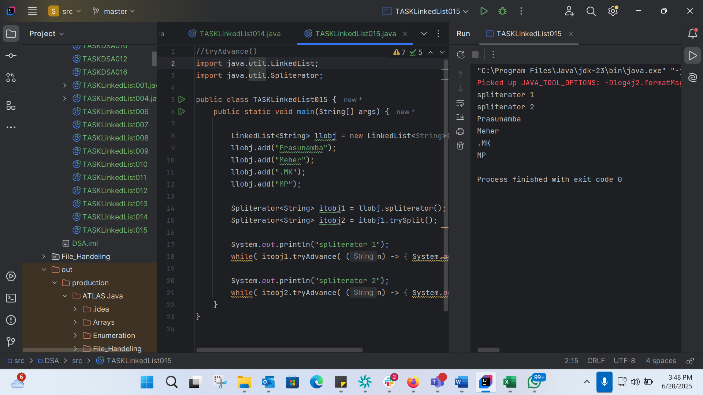
//tryAdvance()
import java.util.LinkedList;
import java.util.Spliterator;
public class TASKLinkedList015 {
public static void main(String[] args) {
LinkedList<String> llobj = new LinkedList<String>();
llobj.add("Prasunamba");
llobj.add("Meher");
llobj.add(".MK");
llobj.add("MP");
Spliterator<String> itobj1 = llobj.spliterator();
Spliterator<String> itobj2 = itobj1.trySplit();
System.out.println("spliterator 1");
while( itobj1.tryAdvance( (n) -> { System.out.println(n); } ) );
System.out.println("spliterator 2");
while( itobj2.tryAdvance( (n) -> { System.out.println(n); } ) );
}
}

TASK 16:
public class TaskLinkedList016 {
// Node class representing each element in the list
static class Node {
int data;
Node prev;
Node next;
public Node(int data) {
this.data = data;
this.prev = null;
this.next = null;
}
}
// Head and tail pointers
Node head;
Node tail;
// Constructor to initialize the list
public TaskLinkedList016() {
head = null;
tail = null;
}
// Method to add a new node at the beginning of the list
public void addAtHead(int data) {
Node newNode = new Node(data);
if (head == null) {
head = newNode;
tail = newNode;
} else {
newNode.next = head;
head.prev = newNode;
head = newNode;
}
}
// Method to add a new node at the end of the list
public void addAtTail(int data) {
Node newNode = new Node(data);
if (tail == null) {
head = newNode;
tail = newNode;
} else {
newNode.prev = tail;
tail.next = newNode;
tail = newNode;
}
}
// Method to print the list in forward direction
public void printForward() {
Node temp = head;
while (temp != null) {
System.out.print(temp.data + " ");
temp = temp.next;
}
System.out.println();
}
// Method to print the list in backward direction
public void printBackward() {
Node temp = tail;
while (temp != null) {
System.out.print(temp.data + " ");
temp = temp.prev;
}
System.out.println();
}
// Method to remove a node from the list
public void removeNode(int data) {
Node temp = head;
while (temp != null) {
if (temp.data == data) {
if (temp.prev != null) {
temp.prev.next = temp.next;
} else {
head = temp.next;
}
if (temp.next != null) {
temp.next.prev = temp.prev;
} else {
tail = temp.prev;
}
return;
}
temp = temp.next;
}
}
public static void main(String[] args) {
TaskLinkedList016 dll = new TaskLinkedList016();
dll.addAtHead(10);
dll.addAtHead(20);
dll.addAtHead(30);
dll.addAtTail(40);
dll.addAtTail(50);
System.out.println("Forward Traversal:");
dll.printForward();
System.out.println("Backward Traversal:");
dll.printBackward();
dll.removeNode(20);
System.out.println("Forward Traversal after removal:");
dll.printForward();
}
}
TASK 17: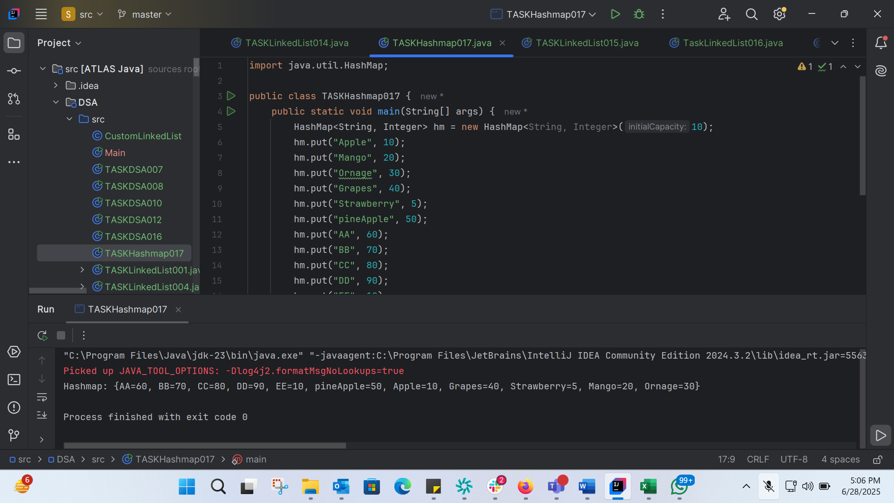import java.util.HashMap;
public class TASKHashmap017 {
public static void main(String[] args) {
HashMap<String, Integer> hm = new HashMap<String, Integer>(10);
hm.put("Apple", 10);
hm.put("Mango", 20);
hm.put("Ornage", 30);
hm.put("Grapes", 40);
hm.put("Strawberry", 5);
hm.put("pineApple", 50);
hm.put("AA", 60);
hm.put("BB", 70);
hm.put("CC", 80);
hm.put("DD", 90);
hm.put("EE", 10);
System.out.println("Hashmap: "+hm);
}
}

TASK 18: 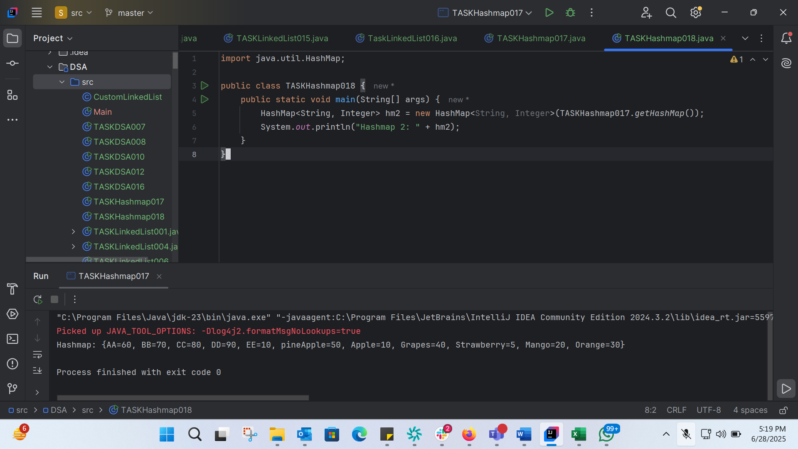
import java.util.HashMap;
public class TASKHashmap018 {
public static void main(String[] args) {
HashMap<String, Integer> hm2 = new HashMap<String, Integer>(TASKHashmap017.getHashMap());
System.out.println("Hashmap 2: " + hm2);
}
}

TASK 19: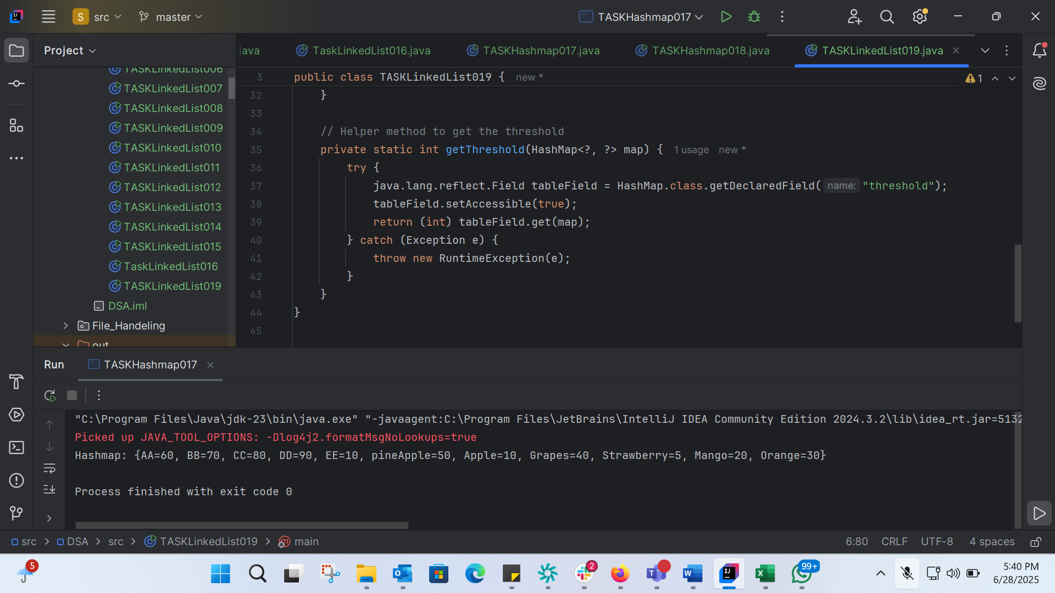
import java.util.HashMap;
public class TASKLinkedList019 {
public static void main(String[] args) {
// Creating a HashMap with initial capacity 10 and load factor 0.75f
HashMap<String, Integer> hm4 = new HashMap<String, Integer>(10, 0.75f);
// Adding elements to the HashMap
hm4.put("Apple", 10);
hm4.put("Mango", 20);
hm4.put("Orange", 30);
hm4.put("Grapes", 40);
hm4.put("Strawberry", 5);
hm4.put("pineApple", 50);
hm4.put("AA", 60);
hm4.put("BB", 70);
// Printing the HashMap
System.out.println("HashMap: " + hm4);
// Checking the size and capacity
System.out.println("Size: " + hm4.size());
System.out.println("Threshold: " + getThreshold(hm4));
// Adding more elements to exceed the threshold
hm4.put("CC", 80);
hm4.put("DD", 90);
hm4.put("EE", 100);
// Printing the HashMap after resizing
System.out.println("HashMap after resizing: " + hm4);
}
// Helper method to get the threshold
private static int getThreshold(HashMap<?, ?> map) {
try {
java.lang.reflect.Field tableField = HashMap.class.getDeclaredField("threshold");
tableField.setAccessible(true);
return (int) tableField.get(map);
} catch (Exception e) {
throw new RuntimeException(e);
}
}
}

TASK 20:
HashMapCreateMethods:

Different methods to create a hashmap in java :
1) Constructing a hashmap with default capacity

ex:
HashMap<String, Integer> hm1 = new HashMap<String, Integer>();

2) Constructing a hashmap with a capacity 10

ex:
HashMap<String, Integer> hm2 = new HashMap<String, Integer>(10);

3)copy one map to another map

ex:
HashMap<String, Integer> hm3 = new HashMap<String, Integer>( hm2);

4)
Specifying load factor along with the capacity

ex:
HashMap<String, Integer> hm4= new HashMap<String, Integer>(10, 0.75f);

Initial capacity ===10
Load factor === 0.75f
TASK 21: 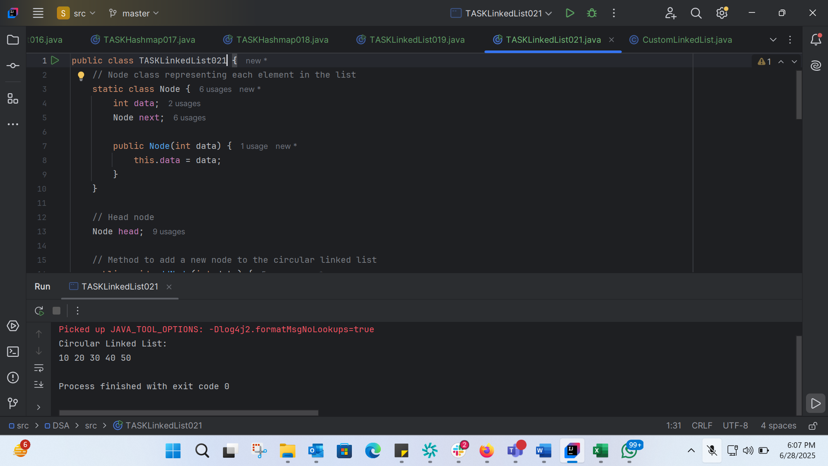
public class TASKLinkedList021 {
// Node class representing each element in the list
static class Node {
int data;
Node next;
public Node(int data) {
this.data = data;
}
}
// Head node
Node head;
// Method to add a new node to the circular linked list
public void addNode(int data) {
Node newNode = new Node(data);
if (head == null) {
head = newNode;
newNode.next = head;
} else {
Node temp = head;
while (temp.next != head) {
temp = temp.next;
}
temp.next = newNode;
newNode.next = head;
}
}
// Method to traverse and display the elements of the circular linked list
public void traverse() {
if (head == null) {
System.out.println("List is empty");
return;
}
Node temp = head;
do {
System.out.print(temp.data + " ");
temp = temp.next;
} while (temp != head);
System.out.println();
}
public static void main(String[] args) {
TASKLinkedList021 cll = new TASKLinkedList021();
cll.addNode(10);
cll.addNode(20);
cll.addNode(30);
cll.addNode(40);
cll.addNode(50);
System.out.println("Circular Linked List: ");
cll.traverse();
}
}

